 | HOW TO GUIDE  Clearing Cache & Cookies in Microsoft Edge

Follow these simple steps to clear your browsing data, cookies, and cached files in Microsoft Edge. This is a quick way to resolve loading issues, sign-in problems, and outdated content on websites.
ℹ Note: Clearing your cache and cookies will sign you out of most websites. Make sure you have your passwords saved or accessible before continuing.

1 Open your Edge History 🕘
Click the three horizontal dots (⋯) in the upper-right corner of Microsoft Edge, then click History. You can also use the keyboard shortcut Ctrl + H to open history directly.
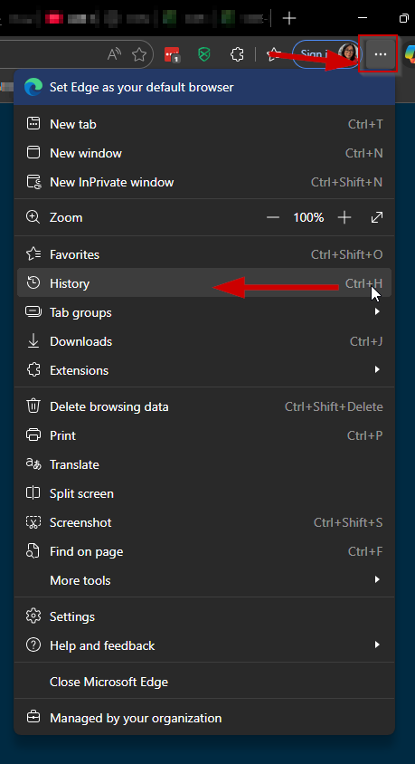
Click the ⋯ menu → History (or press Ctrl + H)

2 Click the trash icon 🗑
When the History panel opens, click the trash icon at the top of the panel. Hovering over it will show the tooltip Delete browsing data.
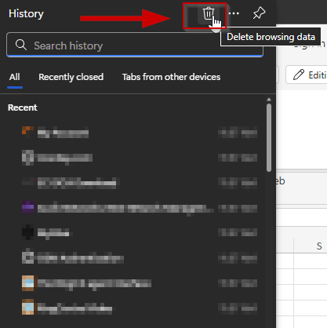
History panel → click the trash (Delete browsing data) icon

3 Select All time and confirm what to clear ✅
In the Delete browsing data window, click the Time range drop-down and select All time. Make sure all of the following options are checked:
• Browsing history
• Download history
• Cookies and other site data
• Cached images and files
When everything is selected, click Clear now.
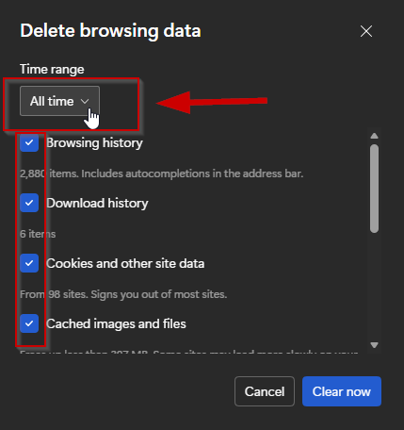
Time range → All time → check all four boxes → Clear now

4 Restart Microsoft Edge 🔄
Close all open Microsoft Edge browser windows, then reopen Edge. This ensures all of your changes take effect and the browser starts with a clean cache.

PRO TIP 💡
If a website still isn’t working correctly after clearing your cache, try opening the site in an InPrivate window (Ctrl + Shift + N). If it works there, the issue is likely a leftover extension or cached file — try disabling extensions one by one to identify the culprit.

