 | HOW TO GUIDE  Clearing Cache & Cookies in Google Chrome

Follow these simple steps to clear your browsing data, cookies, and cached files in Google Chrome. This is a quick way to resolve loading issues, sign-in problems, and outdated content on websites.
ℹ Note: Clearing your cache and cookies will sign you out of most websites. Make sure you have your passwords saved or accessible before continuing.

1 Open your Chrome History 🕘
Click the three vertical dots (⋮) in the upper-right corner of Google Chrome, hover over History, and then click Open history page. You can also use the keyboard shortcut Ctrl + H to open history directly.
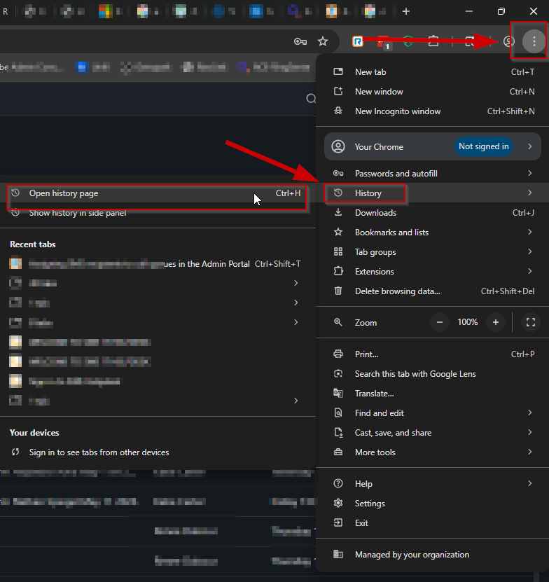
Click the ⋮ menu → History → Open history page (or press Ctrl + H)

2 Click Delete browsing data 🗑
On the History page, look at the left-hand side menu and click Delete browsing data. This will open the Chrome data-clearing dialog in a new tab.
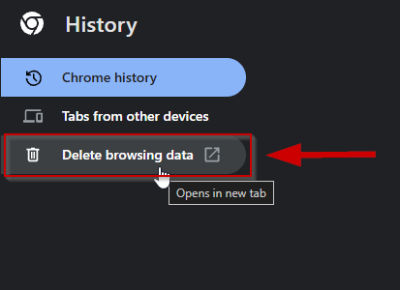
History page → click Delete browsing data on the left side

3 Select All time and confirm what to clear ✅
In the Delete browsing data window, click More and select All time. Make sure the following boxes are checked:
• Browsing history
• Cookies and other site data
• Cached images and files
• Download history
When everything is selected, click Delete from this device.
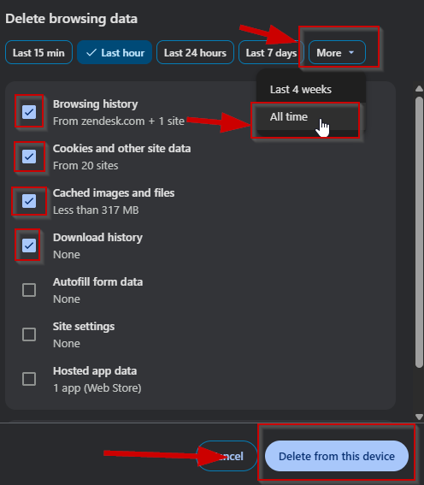
More → All time → check the four boxes → Delete from this device

4 Close and reopen Chrome 🔄
Close all open Google Chrome browser windows, then reopen Chrome. This ensures all of your changes take effect and the browser starts with a clean cache.

PRO TIP 💡
If a website still isn’t working correctly after clearing your cache, try opening the site in an Incognito window (Ctrl + Shift + N). If it works there, the issue is likely a leftover extension or cached file — try disabling extensions one by one to identify the culprit.

