 | HOW TO GUIDE  Changing your Voicemail Greeting

Follow these simple steps to record a personalized voicemail greeting that callers will hear when they reach your mailbox.
ℹ Note: Create your own custom voicemail greeting so callers hear your voice (or message) when they reach your mailbox.

1 Navigate to Voicemail Greeting ⚙
Go to Settings → Voicemail → Voicemail greeting. This opens the screen where you can review or change the message your callers hear.
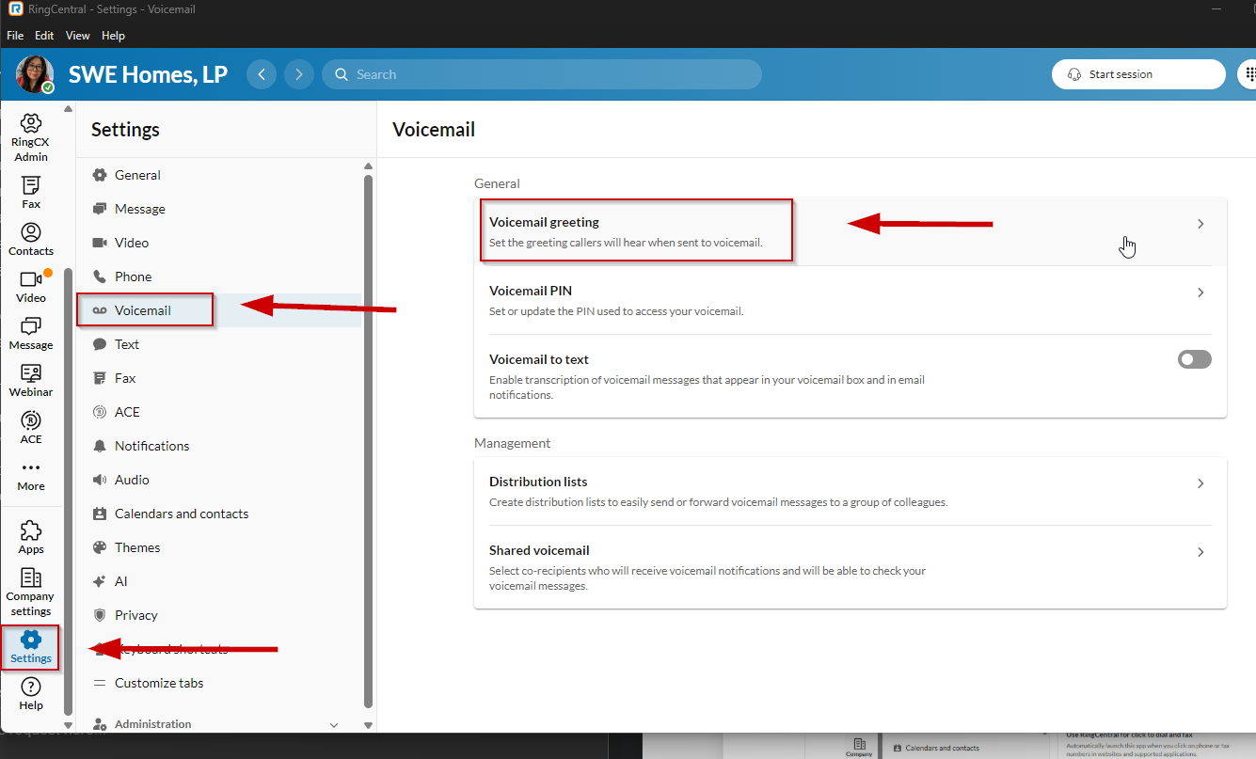
Settings → Voicemail → Voicemail greeting

2 Choose Custom and start recording 🎙
From the Voicemail greeting drop-down, select Custom. When you are ready, click the red record button to begin recording your new greeting.
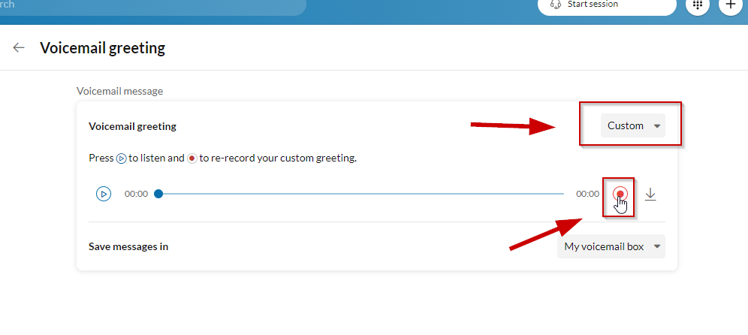
Select Custom from the drop-down, then click Record

3 Record your greeting and Save 💾
Choose how you would like to record: Computer Microphone, Phone (use your deskphone), or Importing (upload a pre-recorded message). Click the record button in the middle to capture your greeting, then click Save when you are done.
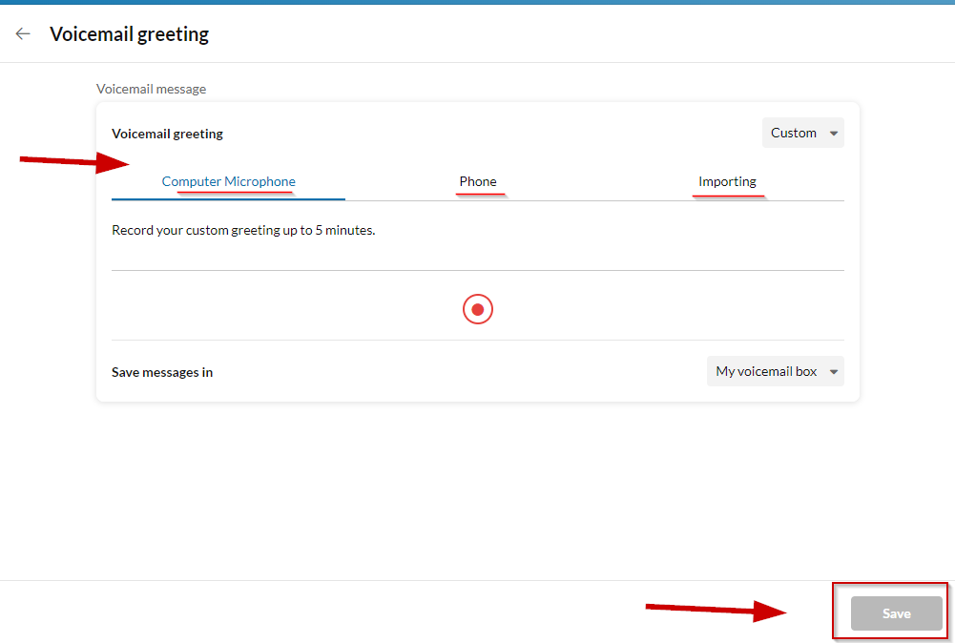
Pick a source (Computer Microphone, Phone, or Importing), then Save

PRO TIP 💡
Speak clearly and keep your greeting short — about 15 to 20 seconds is ideal. Include your name, a brief message, and let callers know when they can expect a callback for the most professional impression.

BONUS TIP
✉ In addition to creating your voicemail greeting, you can also transcribe voicemails. From the main Voicemail menu, toggle on Voicemail to text to receive written transcripts of your messages in your inbox and email notifications.

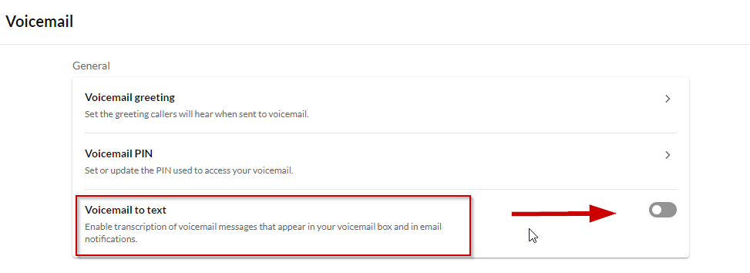
Settings → Voicemail → toggle on Voicemail to text

