 | HOW TO GUIDE  Changing your RingCentral Status

Follow these simple steps to update your RingCentral availability and let your colleagues know what you are working on.
ℹ Note: Setting your status helps your team know whether you are available, in a meeting, or unavailable. Selecting Do not disturb forwards all incoming calls directly to voicemail.

1 Set your availability status 🟢
Click your profile icon in the top-left corner of RingCentral, then click the drop-down arrow next to Available. Select the status you wish to use — Available, Do not disturb, or Invisible. Remember: Do not disturb forwards all incoming calls directly to voicemail.
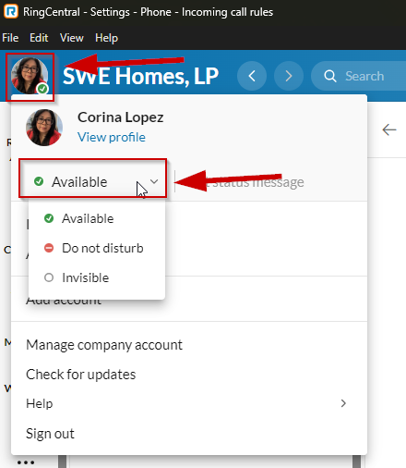
Profile icon → click drop-down next to Available → choose your status

2 Set a custom status message 💬
Click the Set status option to add a custom message or choose from one of the premade messages such as Lunch, In a meeting, Out of office, Out sick, or Working remotely. Type your message (or pick an option), then click Save.
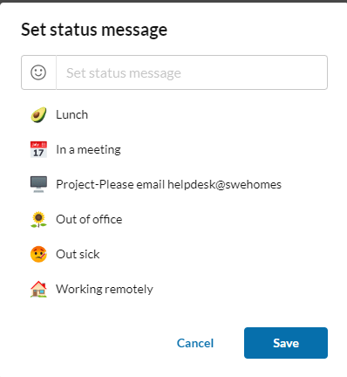
Set status message → choose a preset or type your own → Save

PRO TIP 💡
Custom status messages are only visible to internal employees, so feel free to share specific details (e.g., working on a project, or your return date) to help your teammates reach the right person at the right time.

