 | HOW TO GUIDE  Blocking/Unblocking Numbers in RingCentral

Follow these simple steps to block unwanted callers, review your blocked numbers list, and remove a number when you no longer need it blocked.
ℹ Note: Blocked numbers will not be able to reach you. They will hear a message stating their call cannot be completed. You can review and remove blocked numbers at any time from your settings.

1 Block a number from the Calls tab 🚫
From the Phone menu, click the Calls tab. Locate the number you wish to block, click the three dots (⋯) next to that number, and select Block number from the drop-down menu.
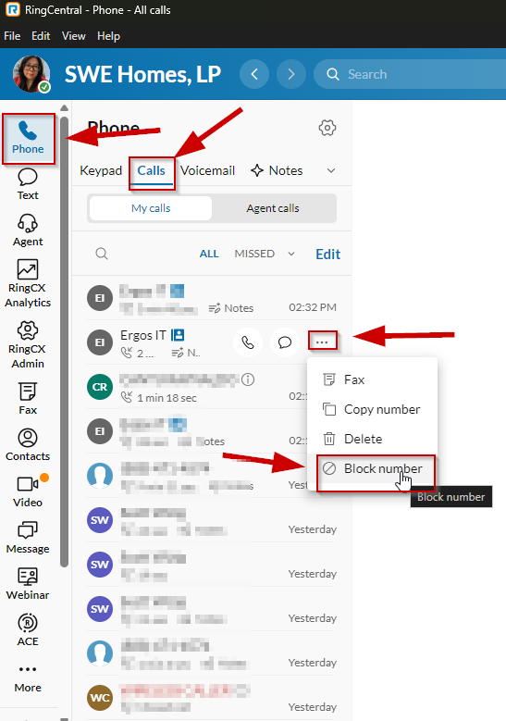
Phone → Calls → click ⋯ next to the number → Block number

2 View your blocked numbers ⚙
To review the numbers you have blocked, go to Settings → Phone, then click Blocked numbers. This is where you manage all of your blocking preferences.
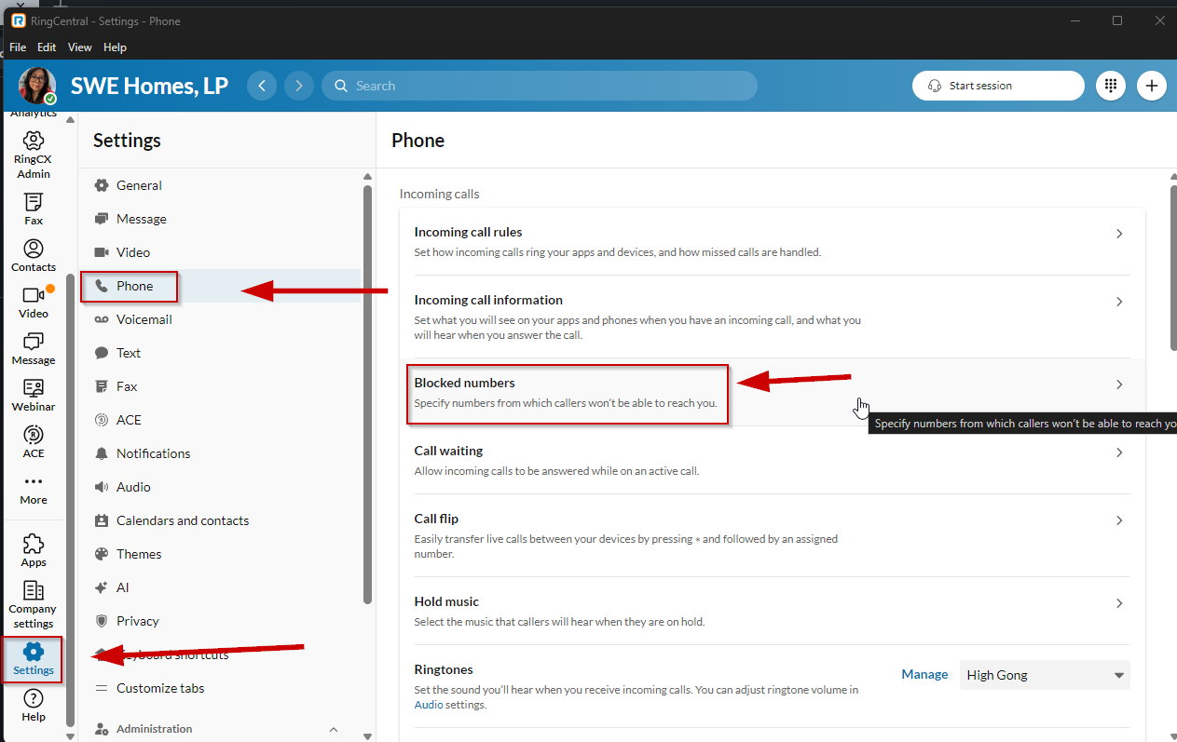
Settings → Phone → Blocked numbers

3 Review your blocked numbers settings 📋
On the Blocked numbers screen, you will see your blocked numbers or area codes, trusted numbers, and General settings — including the blocked call message, Block Robocalls, and Block calls from pay phones.
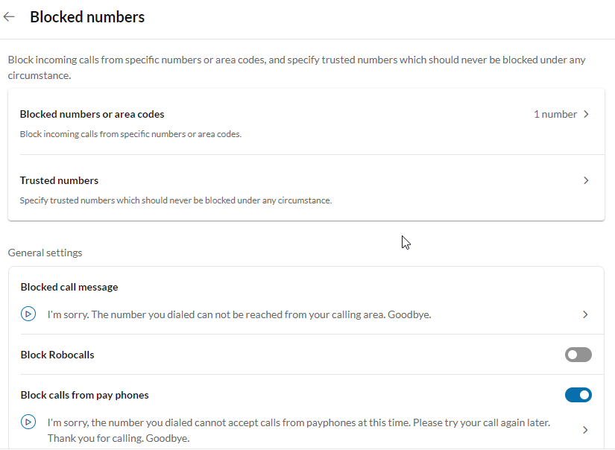
Blocked numbers screen → review numbers, trusted list, and General settings

4 Remove a blocked number 🗑
To unblock a number, click the Blocked numbers or area codes tab. Find the number you would like to remove, then click the trash icon (Delete) next to it.
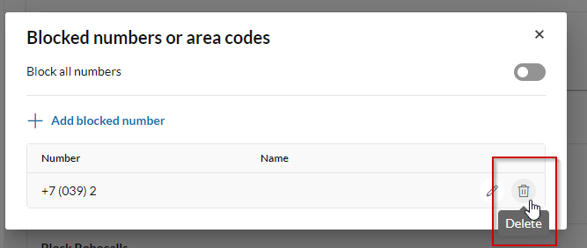
Blocked numbers or area codes → click the Delete (trash) icon

PRO TIP 💡
Use the Trusted numbers list for clients, or vendors, whose calls should never be blocked under any circumstance. You can also enable Block Robocalls in General settings to automatically reduce unwanted spam calls.

